**ID3:**

The ID3 algorithm was most effient at identifying the Sentosa irises. The ID3 algorithm has much more difficulty identifying Vericolor and Virginica irises. This isssue is most pronounced when using a low bin number (K=5). This happenes because the data for Versicolor and Virginica overlaps. Thus the ID3 algorithm did not have enough resolution to determine the difference btween a Versicolor and a Verginica. This issue is alleviated as the number of bins increases. The downside to inccreasing the bin size is that it can cause the algorthim to over fit the data. With this particular data set though, disparity in accuracy between K=15 and K=20 is small. If the bin size were to conitue to grow overfiting would become a larger issue.

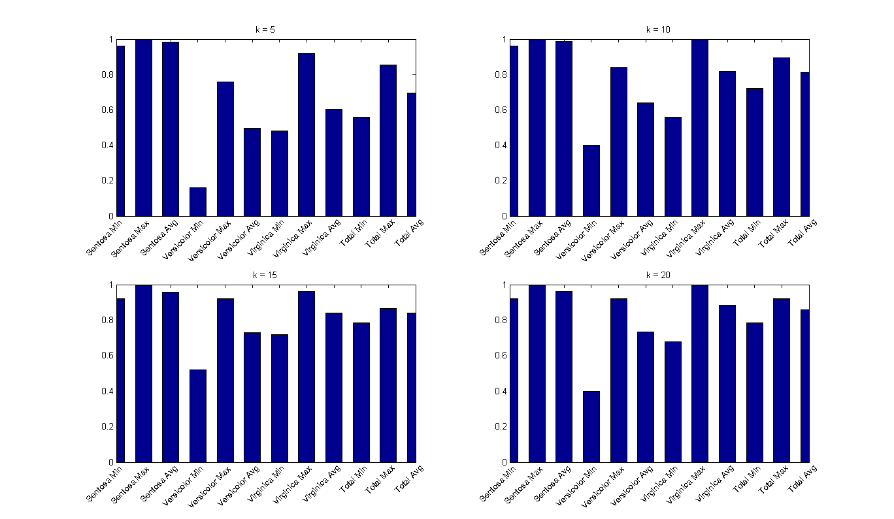

**Naïve Bayes Classifier:**

The Naïve Bayes Classifier had a much harder time correctly distinguishing between Versicolor and Verginica Irises. Like when using the ID3 algorithm the accuracy of the Naïve Bayes classifier improved when the bin size increased. However, even when the bin number was increased to 20 the max accuracy struggled to reach 60%. Like the ID3 algorithm, the Naïve Bayes algorithm was able to successfully identify Sentosa Iris very accurately. In fact, the Naïve Bays algorithm identified the Sentosa Iris correctly 100% of the time. This added accuracy did come at a fairly significant cost of incorrectly identifying the Versicolor and Verginica Irises.

